**Name: Hoang Duc Khanh Student ID: 20155889**

**Lab: Industrial Networks and Power Electronics Laboratory (INPEL)**

Class: MECHANICS AND CONTROL OF ROBOT MANIPULATORS

Instructor: Prof. Kang, Hee-Jun

Home Work 6

Do the following problems about a manipulator shown in the Text Book Fig 6.6. Real parameter m1 = 5kg, m2 = 3kg, l1= l2= 0.5m. Static initial position (θ1, θ2) = (150, 150); static final position (x, y) = ( ); time elapsed 1sec.

1. Set up joint cubic trajectory planning
2. Find Torque trajectory for the obtained trajectory
3. Apply the obtained torque trajectory to the robot at initial position.

Check if you can get the same trajectory as you planed

1. Set up Cartesian trapezoidal trajectory planning for straight line from initial position to final position
2. Find torque trajectory for the obtained trajectory
3. Apply the obtained torque trajectory to the robot at initial position. Check if you can get the same trajectory as you planed.

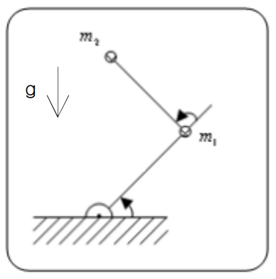

Solutions

1. Set up cubic trajectory:

$$θ_{1\left(t\right)}=a_{10}+a_{11}t+a_{12}t^{2}+a_{13}t^{3}$$

$$θ_{2\left(t\right)}=a_{20}+a_{21}t+a_{22}t^{2}+a_{23}t^{3}$$

The final position is: $\left(x,y\right)=(\frac{-3}{4},\frac{\sqrt{3}}{4})$, so by solving inverse for the final angle for 2 links, we have: $θ_{1}={120}^{°}$ and $θ_{2}={90}^{°}$

Based on these equations about solving the cubic trajectory, then we have:

$$\left\{\begin{aligned}\begin{matrix}a_{10}={15}^{°} & a_{11}=0 & \begin{matrix}a_{12}=285 & a_{13}\end{matrix}=190\end{matrix} \\ \begin{matrix}a_{10}={15}^{°} & a_{11}=0 & \begin{matrix}a_{12}=135 & a_{13}\end{matrix}=90\end{matrix}\end{aligned}\right.$$

The trajectory is:

$${ θ}_{1\left(t\right)}=15+285t^{2}+190t^{3}$$

$$θ_{2\left(t\right)}=15+135t^{2}+90t^{3}$$

1. The torque Trajectory:

The velocity and acceleration along this part:

The velocity:

$${\dot{θ}}_{1\left(t\right)}=570t+570t^{2}$$

$${\dot{θ}}_{2\left(t\right)}=270t+270t^{2}$$

The acceleration:

$${\ddot{θ}}_{1\left(t\right)}=570+1140t$$

$${\ddot{θ}}_{2\left(t\right)}=270+540t$$

The torque trajectory:

$τ_{1}=m_{2}l_{2}^{2}\left({\ddot{θ}}_{1}+{\ddot{θ}}_{2}\right)+m_{2}l_{1}l_{2}c_{2}\left(2{\ddot{θ}}_{1}+{\ddot{θ}}_{2}\right)+\left(m_{1}+m_{2}\right)l_{1}^{2}{\ddot{θ}}_{1}-m_{2}l_{1}l_{2}s_{2}{\dot{θ}}_{2}^{2}-2m_{2}l_{1}l_{2}s_{2}{\dot{θ}}_{1}{\dot{θ}}_{2}+m_{2}l_{2}gc_{12}$ +($m_{1}+m_{2})l_{1}gc_{1}$

$$τ_{2}=m_{2}l_{1}l_{2}c_{2}{\ddot{θ}}_{1}+m_{2}l_{1}l_{2}s_{2}{\dot{θ}}_{1}^{2}+m_{2}l_{2}gc_{12}+m_{2}l_{2}^{2}({\ddot{θ}}_{1}+{\ddot{θ}}_{2})$$

1. Apply the obtained torque trajectory to the initial position:

At the initial the time t equal 0:

So we have:

$${ θ}_{1\left(0\right)}={15}^{°}$$

$${ θ}_{2\left(0\right)}={15}^{°}$$

$${\dot{θ}}_{1\left(0\right)}=0$$

$${\dot{θ}}_{2\left(0\right)}=0$$

$${\ddot{θ}}_{1\left(0\right)}={570}^{°}$$